The University of Azad Jammu and Kashmir,Muzaffarabad



Maryam Shaheen
2024-SE-30
Database Systems
Engr.Awais Rathore

Department of Software Engineering

Lab#11

1. Introduction
In this part of the lab, I continued working with scalar SQL functions in MySQL.
This section focuses on Numeric Functions and Date/Time Functions. Numeric functions are used to perform calculations, rounding, discounts, taxes, and other mathematical operations. Date and time functions are used to extract information from dates, calculate differences between dates, add or subtract periods, and format dates.
The same scalar_lab database containing the Customer and Product tables was used for this part of the lab.

2. Objectives
By completing this lab, I was able to:
- Apply discounts to product prices.
- Calculate sales tax and final prices.
- Use FLOOR and CEIL for numerical calculations.
- Round prices to a specified value.
- Identify products with odd Product IDs.
- Extract year, month, and day information from dates.
- Format dates in a readable form.
- Calculate customers' ages.
- Calculate the number of days since customers joined.
- Find customers based on their joining year.
- Find products launched during the fourth quarter.
- Find customers who joined within a specified period.
- Calculate product age in days.
- Calculate dates after a specified number of days.
- Combine several functions to create a formatted customer summary.

Numeric Functions
Numeric functions perform mathematical calculations, rounding, and other numerical operations.
The main functions used in this part include:

ROUND()
ROUND rounds a number to a specified number of decimal places.

FLOOR()
FLOOR returns the largest integer that is less than or equal to the given number.

CEIL()
CEIL returns the smallest integer that is greater than or equal to the given number.

MOD()
MOD returns the remainder after division.
Date/Time Functions

Date and time functions allow database dates to be analyzed and formatted.
The functions used include:

YEAR()

Returns the year from a date.

MONTHNAME()
Returns the name of the month.

DAYNAME()

Returns the name of the day of the week.

DATE_FORMAT()

Formats a date according to a specified format.

TIMESTAMPDIFF()

Calculates the difference between two dates using a selected unit such as YEAR or DAY.

DATEDIFF()

Calculates the difference between two dates in days.

DATE_SUB()

Subtracts a specified period from a date.

DATE_ADD()
Adds a specified period to a date.

Part B — Numeric and Date/Time Functions
B1 — Apply 15% discount
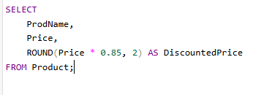

B2 — Calculate 17% sales tax
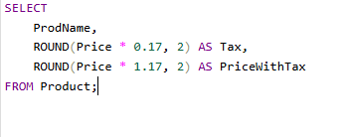


B3 — Floor and ceiling of price divided by 1000
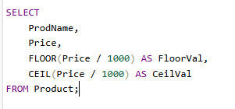


B4 — Round price to nearest hundred
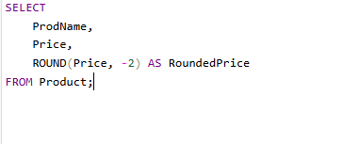

B5 — Products with odd ProdID

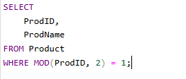

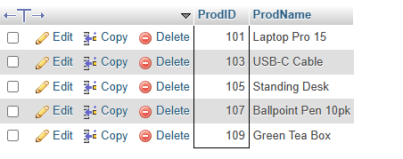
B6 — Year, month name and day of week joined

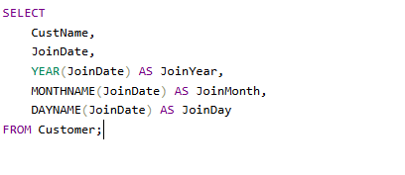
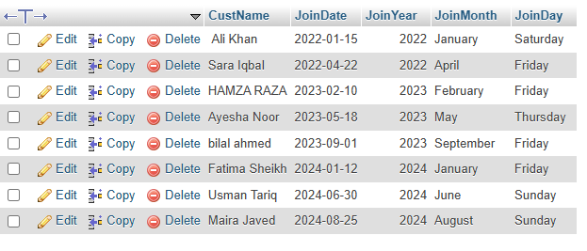
B7 — Format date of birth

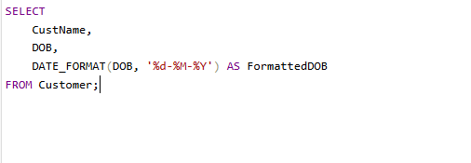
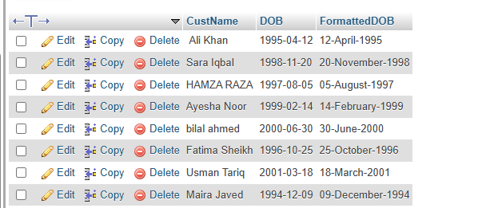

B8 — Calculate current age

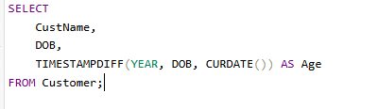
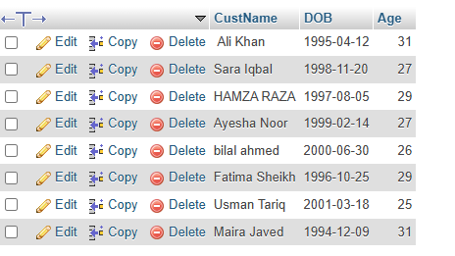
B9 — Days since customer joined

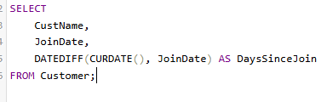
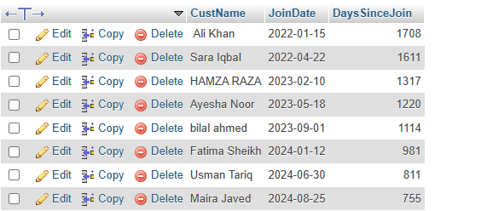

B10 — Customers who joined in 2023

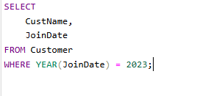
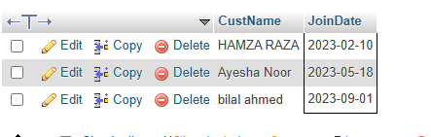
B11 — Products launched in Quarter 4
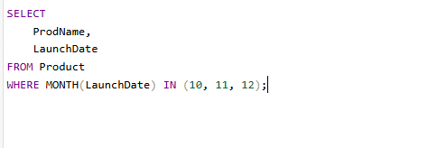
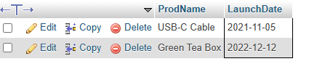
B12 — Customers who joined within last 6 months

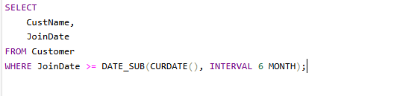
NULL

B13 — Product age in days

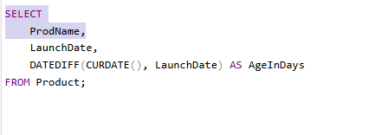

B14 — Date 90 days after launch

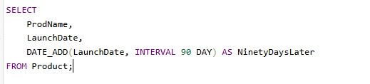
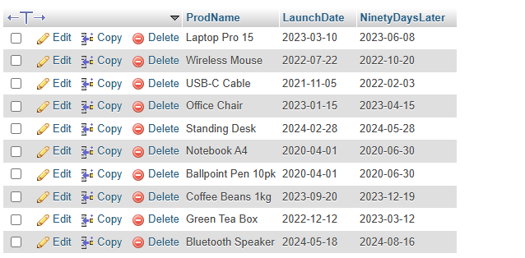

B15 — Combined Summary

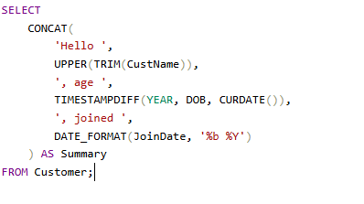

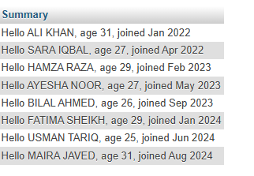
Important Date Formatting
The following DATE_FORMAT() specifiers were useful during the lab:
- %Y — four-digit year
- %m — numeric month
- %M — full month name
- %b — abbreviated month name
- %d — day of month
- %D — day with suffix
- %W — weekday name
- %a — abbreviated weekday name

Result
- I successfully performed numeric and date/time operations on the Product and Customer tables. I calculated discounts, taxes, rounded prices, identified odd Product IDs, extracted date information, calculated ages and date differences, and formatted dates into readable forms.

Conclusion
- In this lab, I learned how to use MySQL numeric and date/time scalar functions. Numeric functions helped me perform calculations and rounding operations, while date/time functions allowed me to analyze customer joining dates, calculate ages, determine date differences, and format dates.

